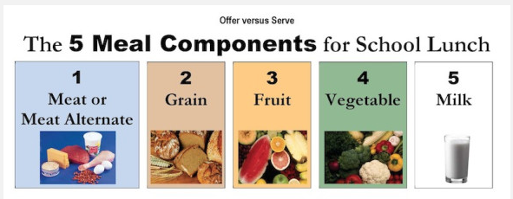
Save Me A Seat Menu Creation

Create a school lunch menu for the week. Each lunch should include the 5 meal components of a school lunch. Turn in to Mrs. Stier by Friday, February 1st to be entered in a drawing for a $25 gift card to try food from a different culture.

*milk is included in all meals | Monday | Tuesday | Wednesday | Thursday | Friday
Meat or Meat Alternate
Grain
Fruit
Vegetable

Name: _____________________________ Teacher: _______________________

